# Virtual coding interview platform

# Project Synopsis Report

Submitted in partial fulfilment of the requirement of the degree of

**BACHELORS OF TECHNOLOGY**

**in**

**CSE**

*To*

**K.R Mangalam University**

*by*

# Shikhar Bajpai (2301010188)

# Priyanshu Tomar (2301010162)

# Ram Ratan Sah (2301010153)

# Kumud Rathi (2301010161)

Under the supervision of

# Mr. Amit



Department of Computer Science and Engineering School of Engineering and Technology

K.R Mangalam University, Gurugram- 122001, India

January, 2025

# INDEX

|  |  |  |
| --- | --- | --- |
| **S. No.** | **TOPICS** | **Page No.** |
| 1. | Abstract | 3 |
| 2. | Introduction (description of broad topic) | 4 |
| 3. | Motivation | 5 |
| 4. | Literature Review | 6 |
| 5. | Gap Analysis | 7 |
| 6. | Problem Statement | 8 |
| 7. | Objectives | 9 |
| 8. | Tools/platform Used | 10 |
| 9. | Methodology | 11-13 |
| 10. | References | 14 |

**ABSTRACT**

It is designed to streamline and enhance the recruitment process by offering a user-friendly, safe, and efficient solution for remote interviews. Built with scalability in mind, this platform enables recruiters to schedule, conduct, and assess candidates in real time. The system utilizes integrated video calling, real-time coding assessments, and automated feedback systems to ensure a seamless experience for recruiters and job seekers alike. This feature delivers video quality while containing end-to-end encryption, ensuring privacy and safety in the entire interview process. Combining modern web technologies and AI-powered tools, this medium will make the remote hiring process easier and streamlined, allowing companies everywhere to be more efficient and make better decisions.

# INTRODUCTION

# In today's digital world, which is increasingly fast-paced, hiring remotely has become an essential aspect of the recruitment process. The virtual interview platform is built to make it more streamlined and convenient for recruiters to connect with their candidates while still providing a smooth, secure, and efficient interview experience. Some of its features include easy scheduling, real-time video interviews, and interactive assessments, allowing recruiters to effectively gauge the skills of the candidates.

# With the friendly-user interface, the platform can be easily accessed by both the candidates and recruiters, thus ensuring that the interview process is smooth and professional. Recruiters can make good judgments based on real-time coding assessments and live interview recordings, using such data to determine performance accurately.

# Moreover, the platform offers end-to-end security and ensures privacy during the entire interview process. Features like automated feedback and performance analysis help simplify the recruitment journey, make it efficient, transparent, and reliable, and create a seamless remote hiring solution.

# MOTIVATION

# The scope of the vision behind this platform should be more than innovative-it should be capable of reaching across industries around the world. Our aspiration is to complete the development of this virtual interview platform as a full-fledged solution, bringing the whole gamut of features to redefine the recruitment process for companies across the world.

# Once done, we hope to pitch this platform to companies, making it an essential tool for streamlining their hiring process. We believe that this platform will not just be a tool, but a game-changer that will fundamentally transform how recruitment is done across industries.

# We have focused on security, user experience, and scalability at every step to ensure that we provide industries with a reliable and future-ready solution. Once fully operational, we plan to sell it globally, giving businesses-from startups to multinational corporations-the best-in-class solution to manage their hiring needs effectively.

# We are committed to bringing this platform out to market and making it the go-to tool for recruitment in every industry. It would be our belief that hiring is going to enter a whole new level of innovation with this platform, and we're excited to scale it globally together with you on this journey.

# LITERATURE REVIEW

# The shift to remote work has significantly shifted the hiring process, and virtual interview platforms have been increasingly adopted. A 2023 survey of LinkedIn shows that 50% of companies have moved to remote interviews, propelling with the COVID-19 pandemic. In-person interviews are naturally time-consuming and geographically restrictive, whereas video platforms break these barriers, unlocking the talent pool (Brown & Williams, 2022).

# Video interviewing is an integral part of remote hiring. A Glassdoor report in 2022 revealed that 76% of recruiters utilize video interviews since they help evaluate both qualifications and communication skills. Technical problems such as poor video resolution or internet connectivity might break the interview process entirely (Liu, 2020). Platforms have started allowing real-time coding assessment of skills through them, thereby increasing the specificity of technical skill evaluation, particularly for technical positions (Nguyen, 2021).

# Security and privacy concerns are critical in virtual hiring, with over 80% of organizations concerned about data breaches (Cybersecurity Ventures, 2022). Therefore, secure login systems and end-to-end encryption are essential for protecting interview content.

# Looking forward, AI and machine learning will play an increasingly important role in automating initial screenings, improving the recruitment process, and enabling more efficient hiring (Bennett, 2023).

# Virtual interview platforms are changing the recruitment landscape rapidly with efficient, scalable, and secure solutions. With remote hiring growing day by day, the need for advanced and user-friendly platforms will increase, thereby opening opportunities for innovation in the recruitment process.

# .

# GAP ANALYSIS

# Current Challenges in Remote Hiring:

# Fragmented Systems: Many recruitment systems focus entirely on a single aspect of the hiring process (e.g., video interviews or candidate testing), but they lack integration with other critical functions like scheduling, feedback, and recruitment analytics.

# Lack of Real-Time Updates: Many existing platforms do not give instant notifications for changes in interview schedules, candidate progress, or interview feedback. This lack of instant notifications creates delays and miscommunications, especially in accelerated hiring scenarios.

# Limited Stakeholder Access:

# Recruiters often juggle between multiple platforms for scheduling, assessments, and interview management.

# Candidates have to use different tools for communication, coding tests, and video interviews, leading to confusion.

# Hiring Managers lack a centralized dashboard to track interview progress, feedback, and candidate evaluations, leading to inefficiencies in decision-making.

# Admins rely on manual reporting and updates, causing unnecessary delays in tracking the recruitment pipeline.

# Rigid and Non-Adaptive Solutions: Most platforms do not have support for varied interview types (e.g., technical screenings, behavioral interviews, and group interviews) or adjustable schedule options, which hinders their capacity to adapt to different organizational needs.

# PROBLEM STATEMENT

* Remote hiring platforms are often fragmented, with the utilization of multiple tools for video interviews, testing, scheduling, and feedback, which in turn creates inefficiencies.
* Recruiters and hiring managers are forced to juggle multiple systems, leading to poor communication and extended delays.
* Candidates face uncertainty with the use of multiple platforms for different aspects of the interview process.
* The lack of real-time updates regarding interview scheduling, candidate movement, and feedback leads to miscommunication and frustration.
* Existing platforms are rigid and do not support dynamic features like hybrid interviews or adaptive scheduling, which are necessary to meet a range of recruitment needs.
* Lack of centralized dashboards and reports for recruiters and administrators makes performance tracking difficult and prevents effective decision-making..

# OBJECTIVES

The key objectives of the Virtual Coding Interview Platform are outlined as follows:

• To create a holistic platform for secure, real-time virtual interviews that includes coding challenges and video interactions.

• To incorporate an automated scheduling mechanism, thus enabling the management of interview time for recruiters and candidates, including support for time zone considerations.

• To provide real-time feedback and assessment integration, enabling recruiters to efficiently evaluate the technical and soft skills of candidates during the interview process.

• To integrate video conferencing capabilities, enabling secure and high-quality communication between interviewers and candidates.

• To create a centralized dashboard for recruiters and administrators, enabling effective monitoring of candidate progress, feedback management, and report generation.

# Tools/Technologies Used

* **Frontend**: React.js, HTML/CSS, JavaScript
* **Backend**: Node.js, Express.js, Socket.io
* **Database**: MongoDB, Mongoose
* **Real-Time Communication**: WebRTC, Socket.io
* **Deployment**: Docker, Heroku / AWS
* **Compiler Integration**: JDoodle API, Replit API, Judge0 (for coding assessments)

*Note: These technologies are currently being worked on and may be subject to change.*

# METHODOLOGY

1. **Requirement Gathering:**

Identifying key features (video interviews, scheduling, coding assessments) and defining user needs (recruiters, candidates, hiring managers).

1. **System Design:**

Designing a modular, scalable platform with a user-friendly interface, focusing on seamless integration of video calls, assessments, and feedback.

1. **Development:**

Using React.js for frontend, Node.js and Convex for backend, and integrating real-time communication with Stream.io .

1. **Compiler Integration:**

Integrating monaco-editor for coding assessments.

1. **Testing & Deployment:**

Testing with Jest and Mocha, and deploying the platform on vercel for high availability.

1. **Monitoring & Maintenance:**

Continuously improving the platform based on user feedback.

**Entity-Relationship Diagram**

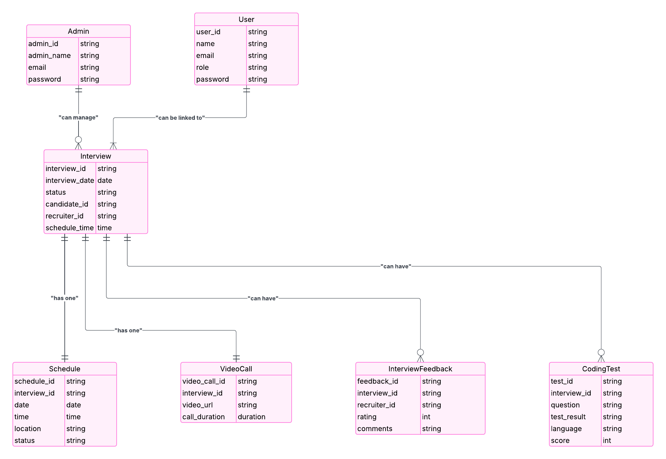

*Note:  
This ERD is not final and may be updated as the project progresses.*

**Source-** Lucidchart

**Data Flow Diagram (DFD)**

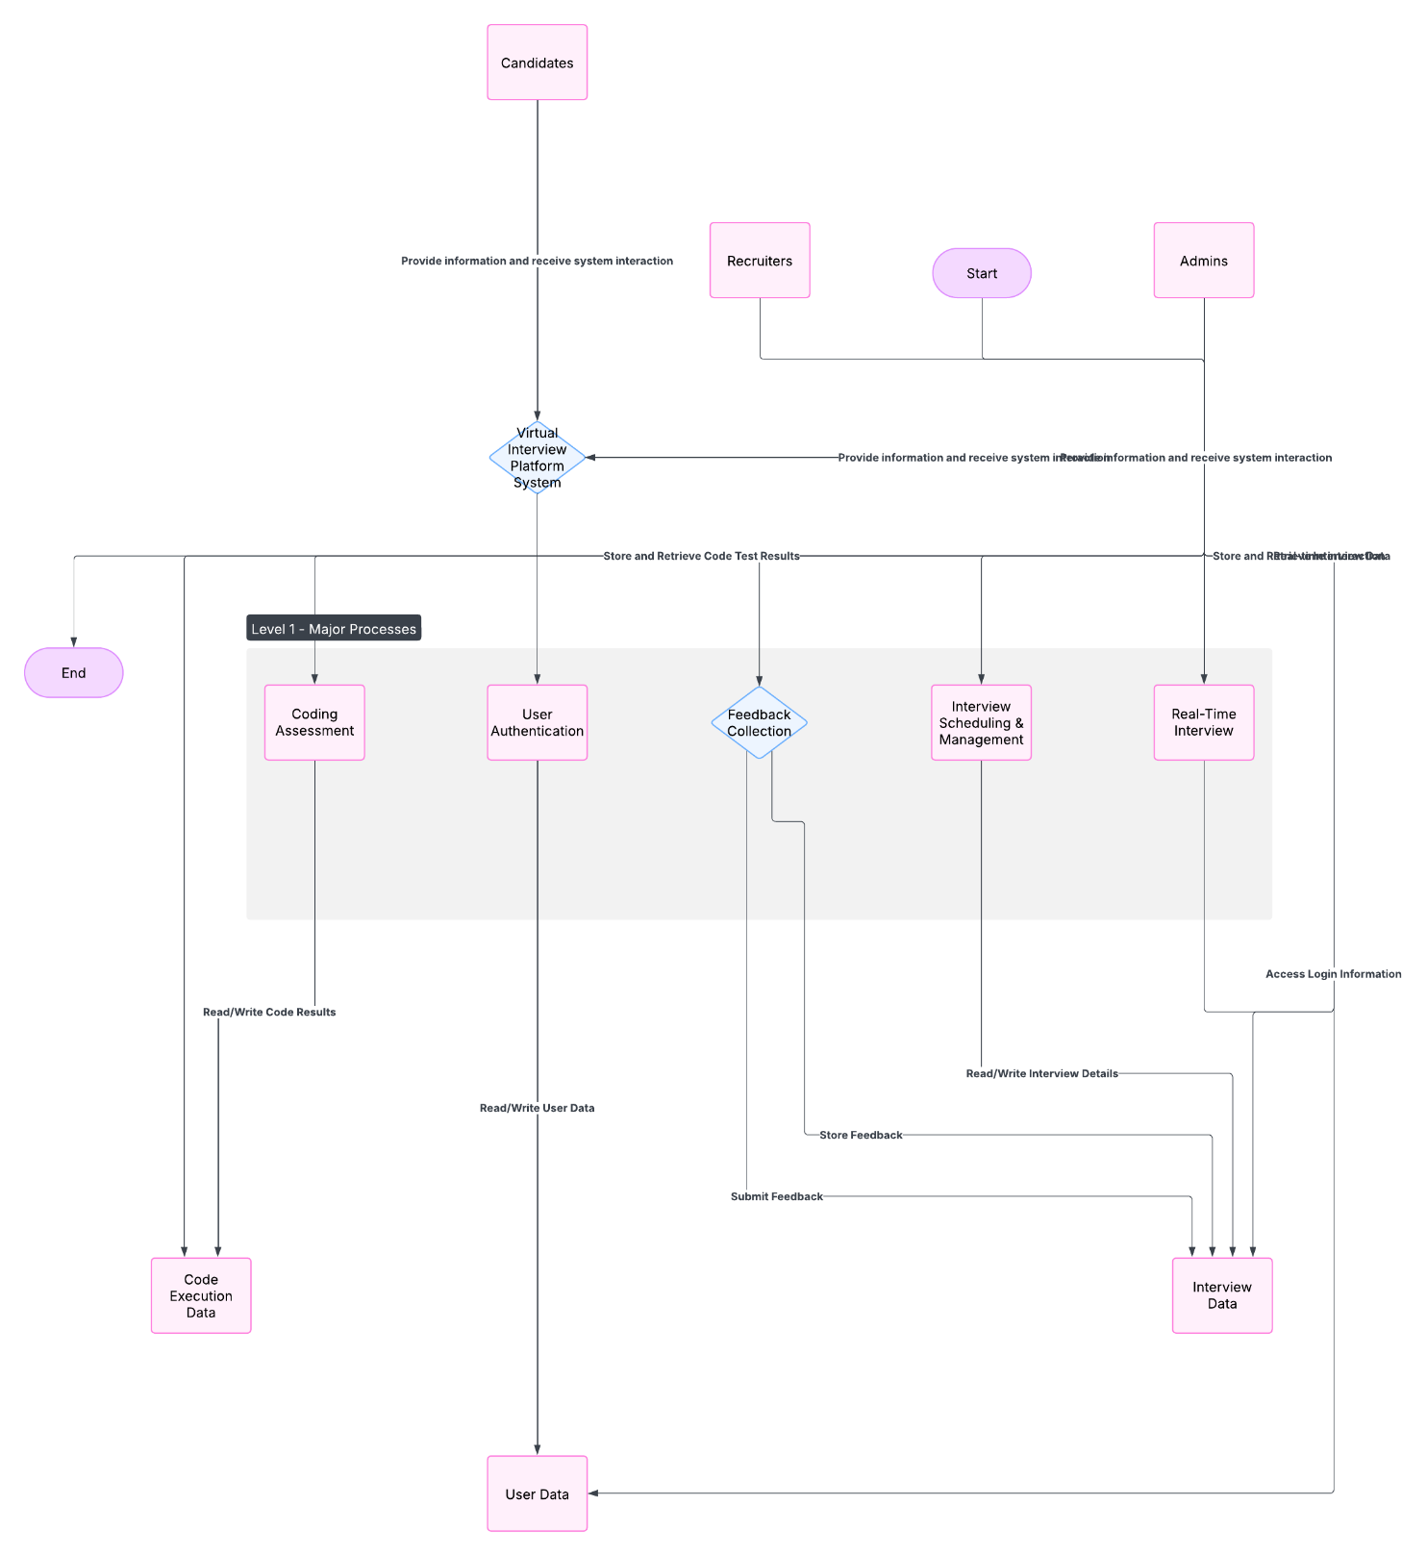

*Note:  
This DFD is not final and may be updated as the project progresses.*

**REFERENCES**

1. Google Scholar. (n.d.). "Platforms for Remote Interviews: Issues and Remedies." Accessed at https://scholar.google.com
2. Patel, R., & Sharma, K. (2023). "The Significance of Real-Time Communication in Online Interviews." Journal of Online Education, 18(4), 112-118.
3. Zhang, L., & Lee, J. (2022). "Employing WebRTC for Efficient Video Interviewing." International Journal of Software Engineering, 27(2), 80-88.
4. AWS. (n.d.). "Solutions Based on Cloud Technology for Applications of Video Conferencing." Amazon Web Services. Accessed at https://aws.amazon.com
5. JDoodle. (n.d.). "Execution of Code in Real Time for Digital Interviews." Accessed at https://www.jdoodle.com/
6. Replit. (n.d.). "Platforms for Collaborative Coding for Prompt Assessments." Accessed at https://replit.com